**Conversation Log**

Below are some screenshots and annotation of the conversation between the chatbot and the user

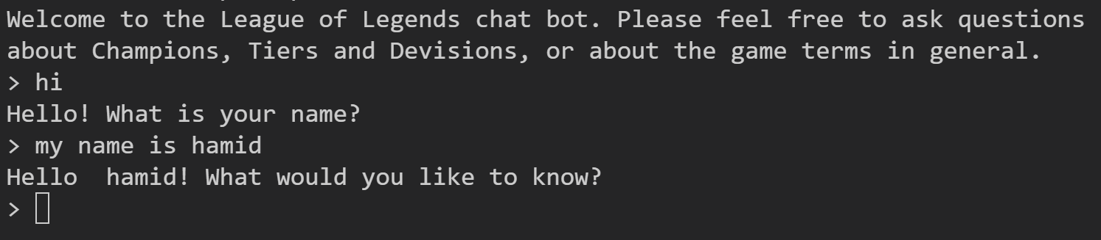

As you can see, when the chatbot runs, it gives a brief introduction about itself. After the user types in hello, it will respond back and then question the user and wait for their response. making it more human like. After the user inputs their name, it saves it into a variable and calls it.

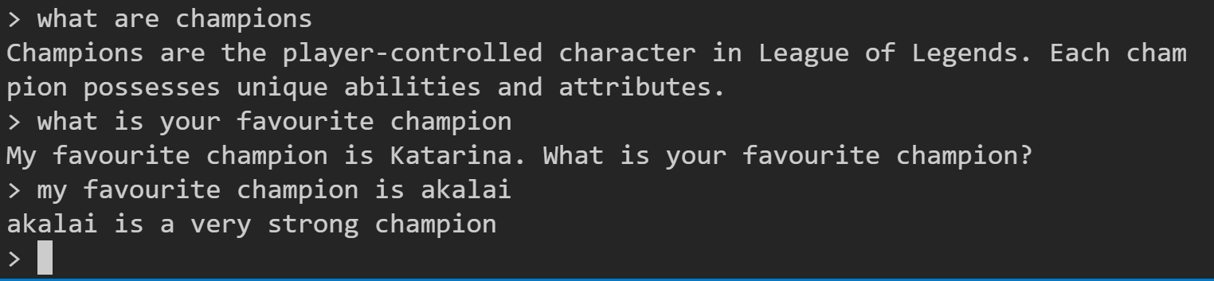

Here you can see the user asking basic stuff about the game such as what the champions are to which the bot gives a brief explanation on. The user then asks the bot who their favourite champion is to which the bot replies and then returns the question. When the user inputs the name of their favourite champion, the bot gives it’s opinions.

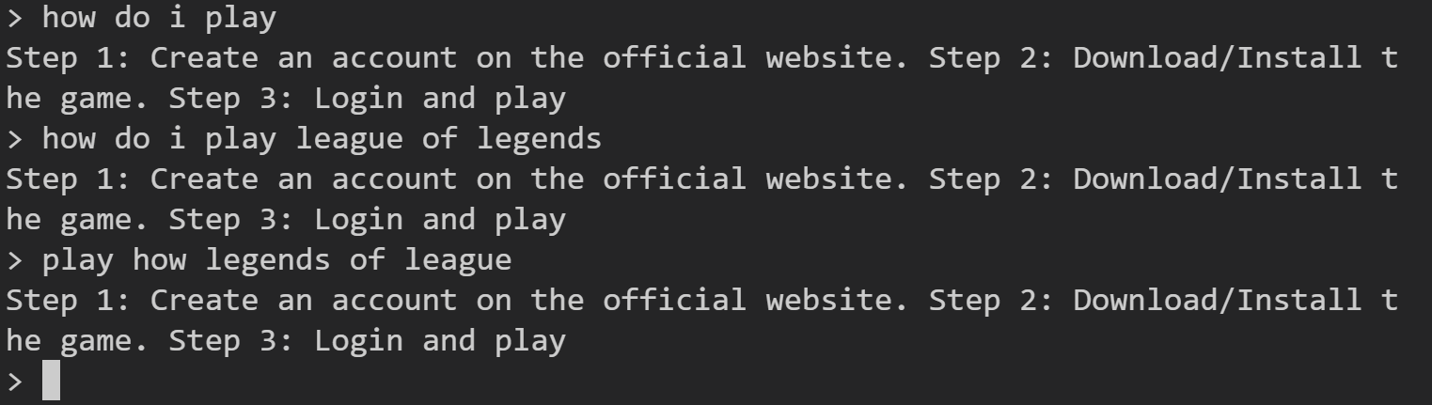

In this instance, you can see the user inputs how to play to which the bot responds with an appropriate answer. However, the user asks the same question but slightly different to which the bot uses the AIML rules (i.e. srai tag) to learn what the user meant and give correct response. On the other hand, the third input is in a very complicated format and isn’t even a proper sentence. So the bot uses the cosign similarity to determine the correct response.

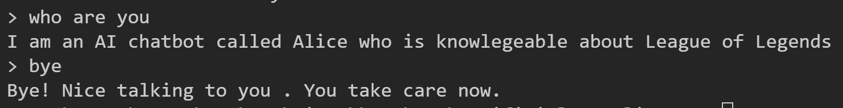

After the user has finished conversating with the bot, he then inputs ‘bye’ or ‘Goodbye’ to which the bot will respond with goodbye message and the bot stop running.